Nama : Aisatul Mutoharoh

NIM :18090107

Kelas : 5B

**PRAKTIKUM 3**

1. Source Code

Matakuliah.php-> application/controller

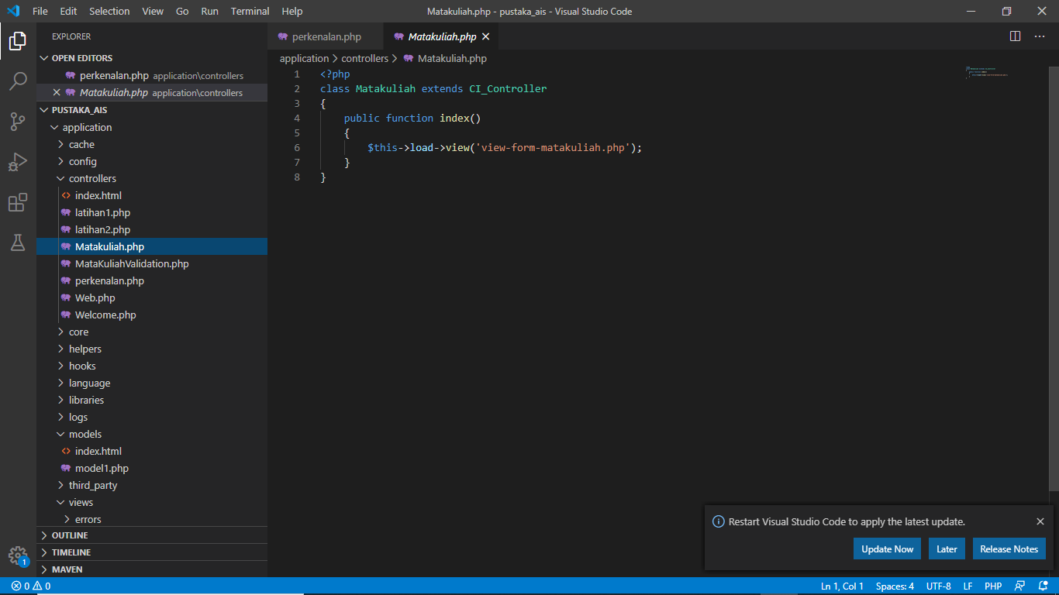

View-form-matakuliah.php->application/view

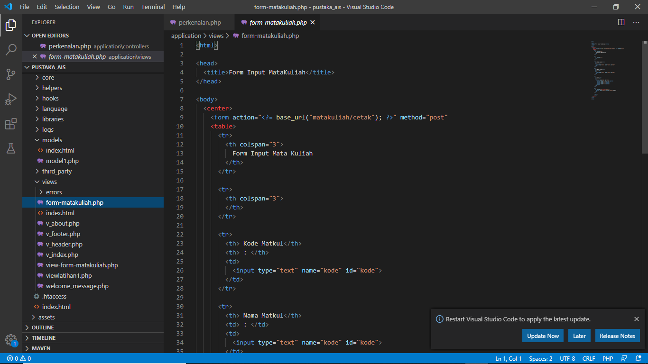

1. URL

<http://localhost/pustaka_ais/index.php/Matakuliah>

1. Capture Hasil

